Unit 2
Assignment
Long Vy
Purdue Global
IN450 – Advanced Software Development Using Python
Brian Myers
April 6, 2026
Create and Copy data into Table IN450A
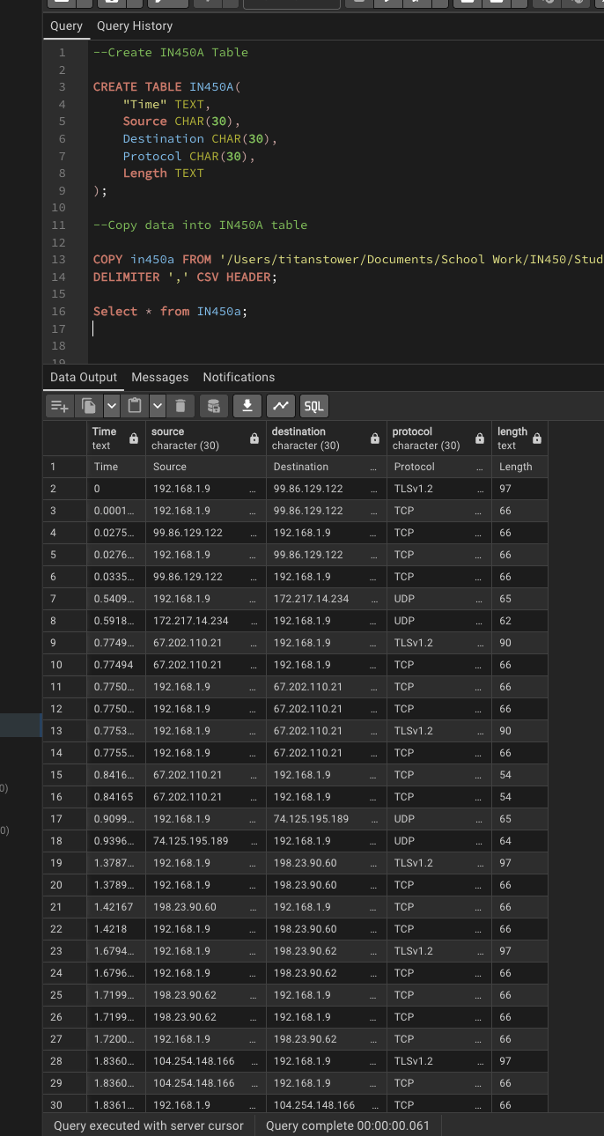
Create and Copy data into Table IN450B
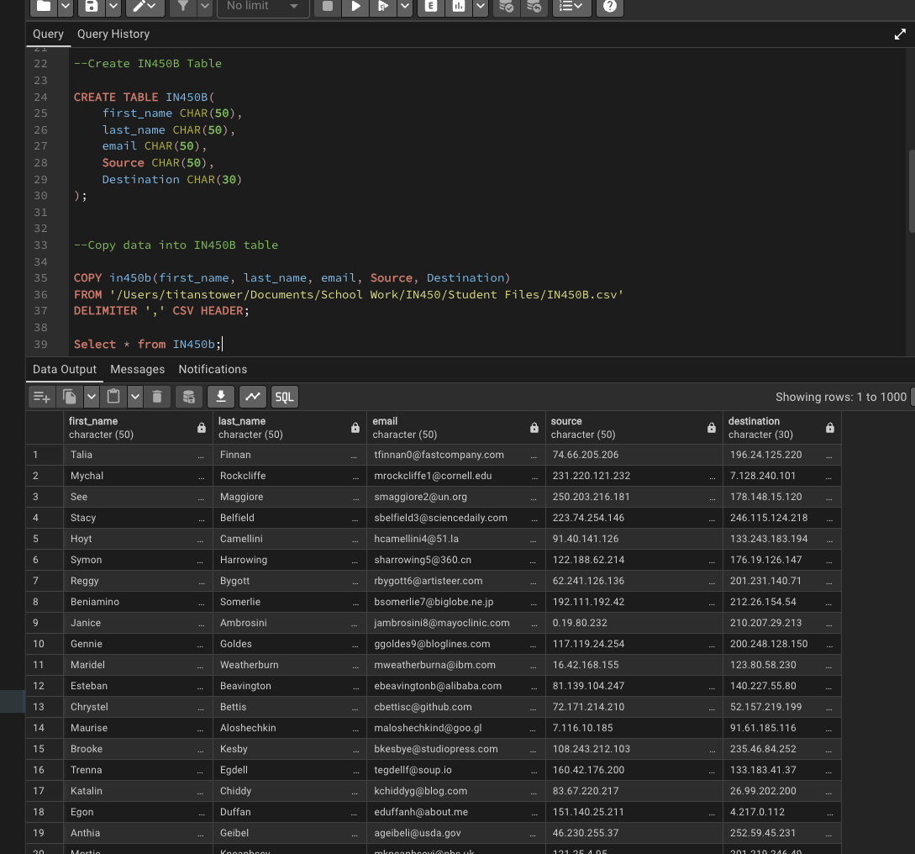
Create and Copy data into Table IN450C
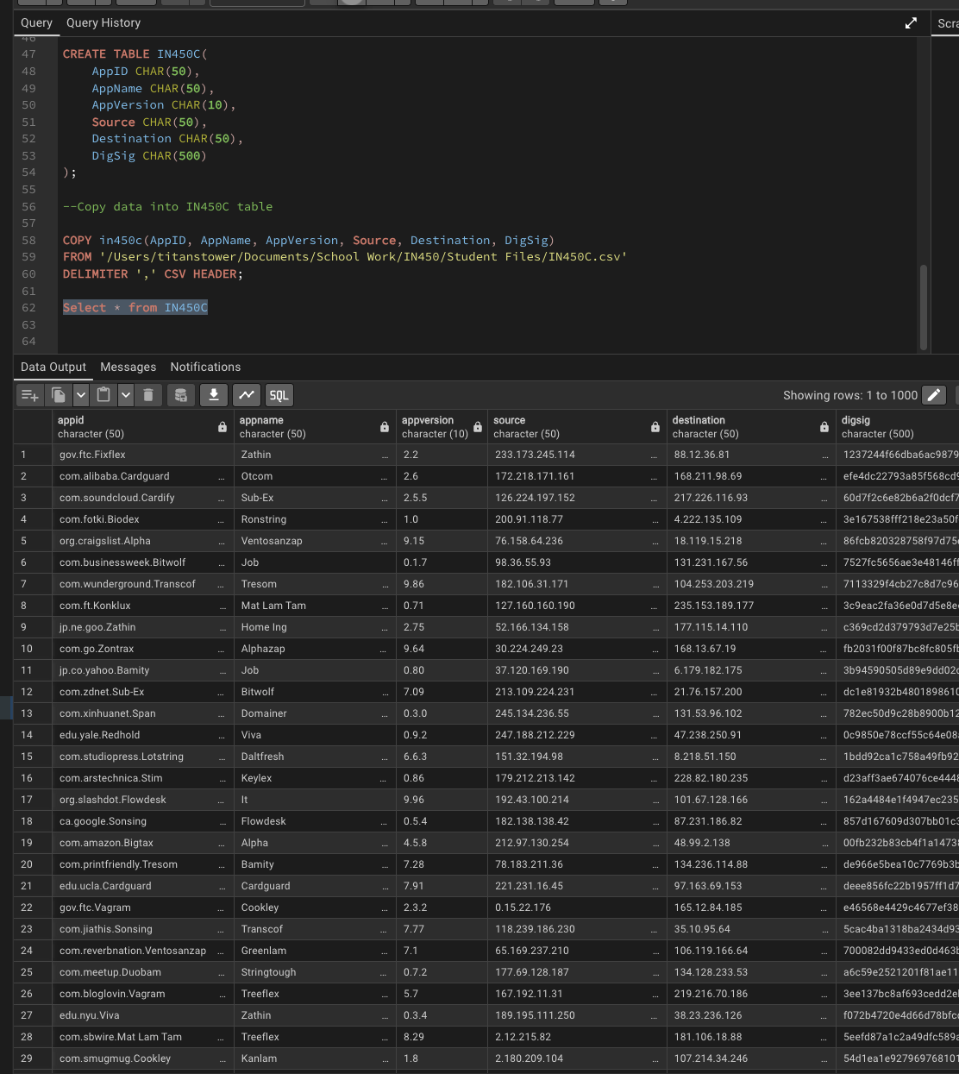

Presentation Layer Code
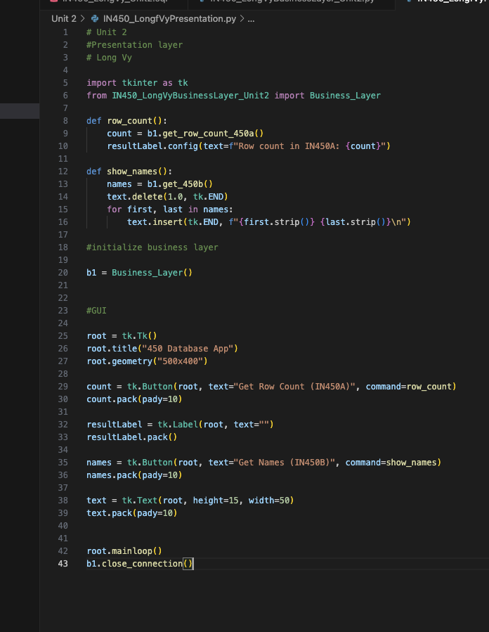
Business Layer Code
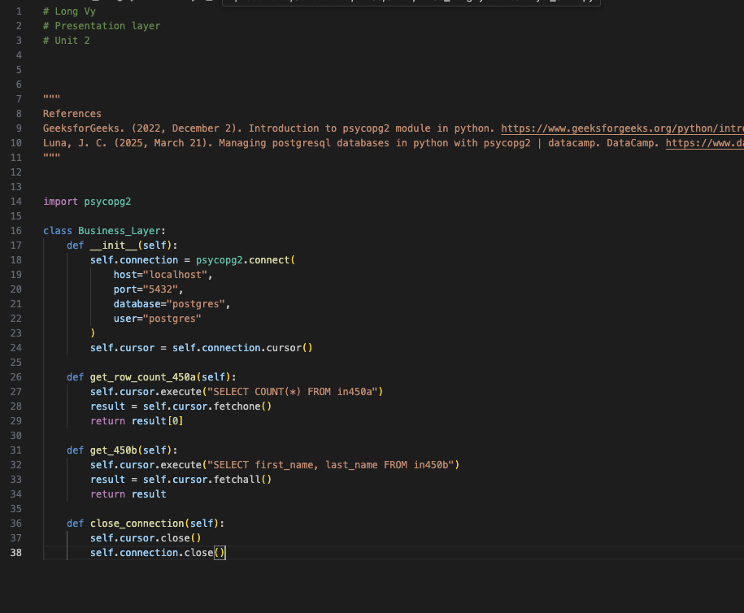
App Starts
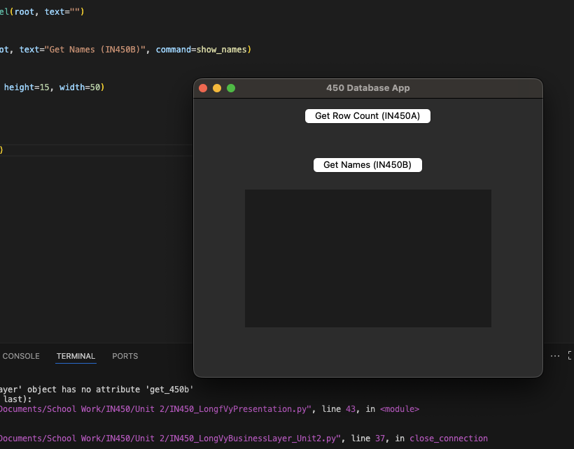

Results
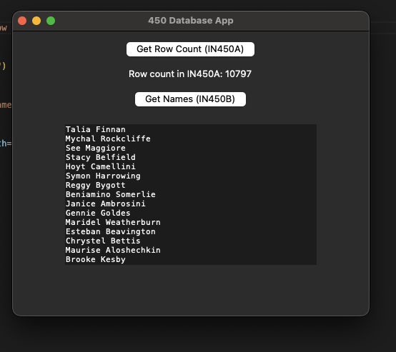
References
GeeksforGeeks. (2022, December 2). Introduction to psycopg2 module in python. https://www.geeksforgeeks.org/python/introduction-to-psycopg2-module-in-python/
GeeksforGeeks. (2026, January 23). Python tkinter. https://www.geeksforgeeks.org/python/python-gui-tkinter/
Luna, J. C. (2025, March 21). Managing postgresql databases in python with psycopg2 | datacamp. DataCamp. https://www.datacamp.com/tutorial/tutorial-postgresql-python

